generalized impedance converters (gyrators) & equalizers
Author: Tyler B. Long
Assignment: ECET 4320 Lab #9
Date Assigned: 11-09-09
Date Submitted: 11-23-09
Department: ECET

SOUTHERN POLYTECHNIC STATE UNIVERSITY

TABLE OF CONTENTS

Section Title Page
1. Introduction 4
2. Design Parameters 4
2.1 Gyrator Circuit 1 4
2.2 Gyrator Circuit 2 4
3. Calculations & Results 4
3.1 Gyrator Circuit 1 5
3.2 Gyrator Circuit 2 6
4. Analysis 9
4.1 Gyrator Circuit 1 10
4.2 Gyrator Circuit 2 11
5. Conclusion 11
6. Appendix A: Lab Documents 12

LIST OF FIGURES
Figure Title Page

Figure 1: Circuit 1 6
Figure 2: Circuit 2 7
Figure 3: Max Boost CAT Plot 8
Figure 4: Max Cut CAT Plot 9

LIST OF TABLES
Table Title Page

Table 1: Circuit 1 PSpice Data 6
Table 2: Circuit 2 PSpice Data 7
Table 3: Circuit 2 CAT Data 8
Table 4: Lab Equip. S/N 10

1. Introduction

This lab report will discuss two design topics: Equalizer and Gyrator design techniques. The two designs will use a common equalizer circuit with two different methods for synthesizing inductors known as gyrators. The Generalized Impedance Converter (GIC) will be used for Circuit 1 in Section 2.1 in order to simulate an ideal inductor as well as its respective series losses. The simple gyrator used in Circuit 2 Section 2.2 will simulate an ideal inductor as well as its series and parallel losses. As Gyrator Circuit 2 in Section 2.2 was the only one measured during lab, the PSpice plots will be used to compare the differences between Gyrator Circuit 1 in Section 2.1 and Gyrator Circuit 2 in Section 2.2. See Appendix A for PSpice plots.

2. Design Parameters

The following is an overview of the design parameters required for each circuit.

2.1 Gyrator Circuit 1

- Center frequency: 1587.4 Hz
- +16dB Max boost capability at given center frequency
- -16dB Max cut capability at given center frequency
- Quality Factor (Q): 2
- R_{IN} = R_{F} = 10kΩ ; contains 50kΩ potentiometer
- Use Gyrator Circuit 1 to simulate inductor

2.2 Gyrator Circuit 2

- Same as above except: Use Gyrator Circuit 2 to simulate inductor

3. Calculations & Results

The following will show the methods used to achieve the component values for each circuit, the results from the PSpice plots and the measured values from the CAT system (Circuit 2 only).

3.1 Gyrator Circuit 1

See Appendix A for hand calculations.
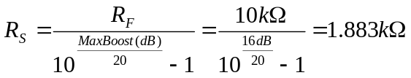
Equation 1: Circuit 1 Rs

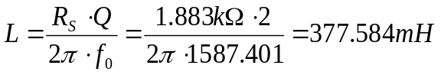
Equation 2: Circuit 1 L

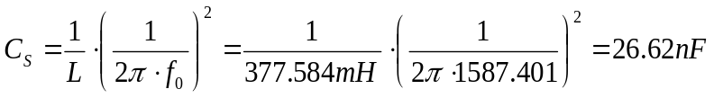
Equation 3: Circuit 1 Cs

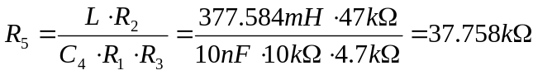
Equation 4: Circuit 1 R5

As shown above in Equation 4, values for R₁, R₂, R₃, and C₄ were chosen in order to both coerce R₅ close to a standard resistor value and to maintain all resistor values between the 2.2kΩ and 240kΩ standard. This will ensure that the TL072 is properly loaded as well as the final circuit having minimal noise due to relatively high resistor values.

The single band equalizer and GIC shown in Figure 1 were constructed in PSpice based on the calculations given above.
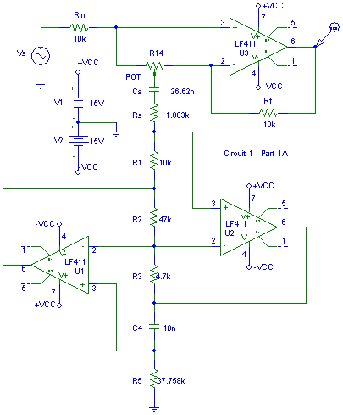
Figure 1: Circuit 1

Table 1 below correlates the design requirements to the PSpice plots of Circuit 1.
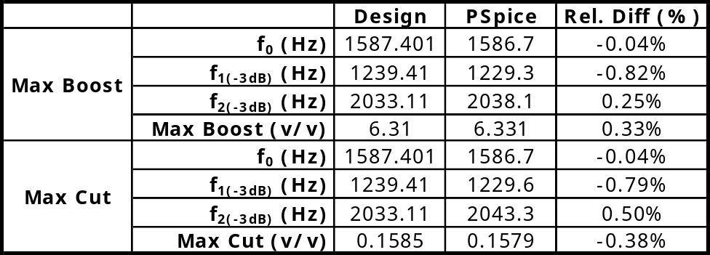
Table 1: Circuit 1 PSpice Data

3.2 Gyrator Circuit 2

See Appendix A for hand calculations.
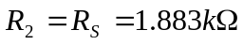
Equation 5: Circuit 2 R2

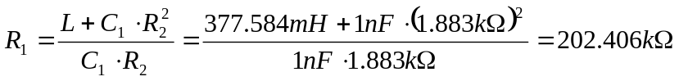
Equation 6: Circuit 2 R1

As shown above in Equation 6, the value C₁ was chosen in order to coerce R₁ into a standard resistor value within certain limits as discussed earlier in Section 3.1. The single band equalizer and simple gyrator shown in Figure 2 were constructed in PSpice based on the calculations given above.
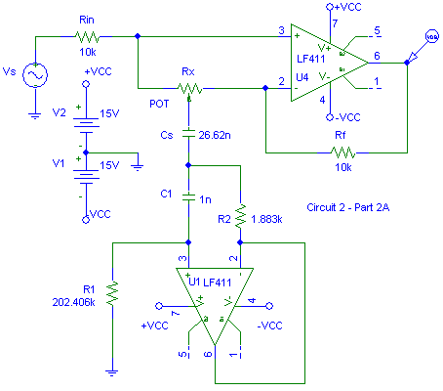
Figure 2: Circuit 2

Table 2 below correlates the design requirements to the PSpice plots of Circuit 2.
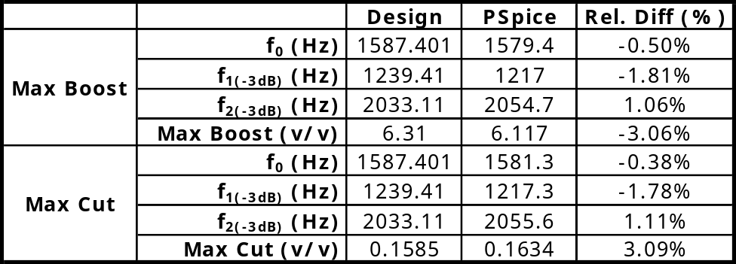
Table 2: Circuit 2 PSpice Data

Table 3 below correlates the PSpice plots to the CAT system measurements of Circuit 2.
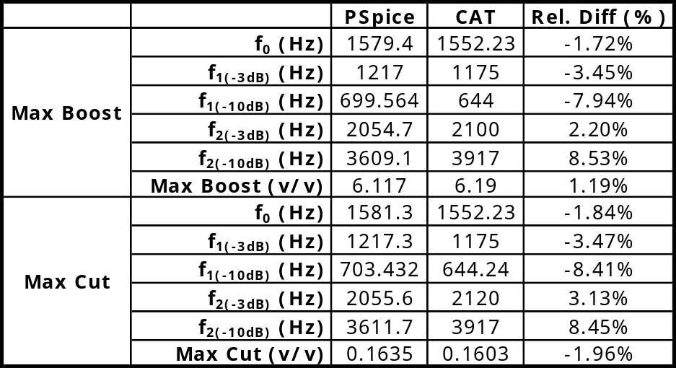
Table 3: Circuit 2 CAT Data

Figure 3 below shows the CAT plot for the maximum boost configuration.

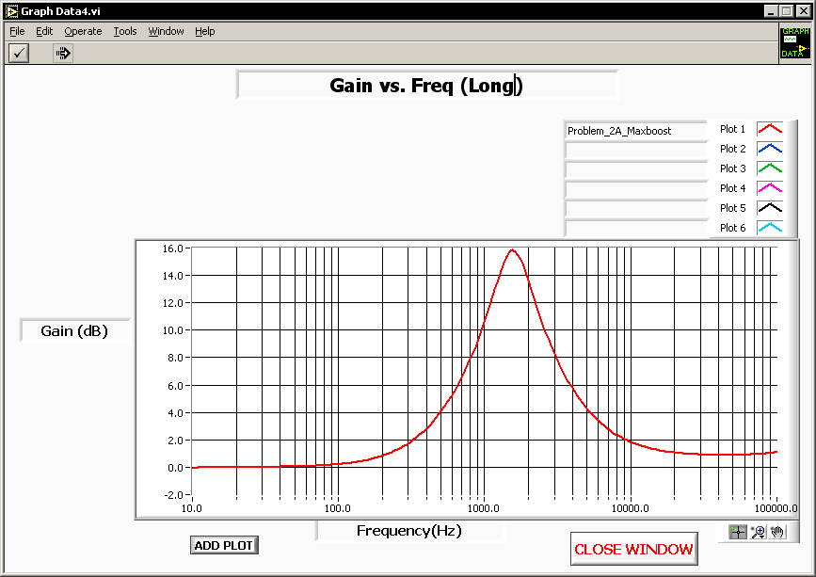
Figure 3: Max Boost CAT Plot

Figure 4 below shows the CAT plot for the maximum cut configuration.

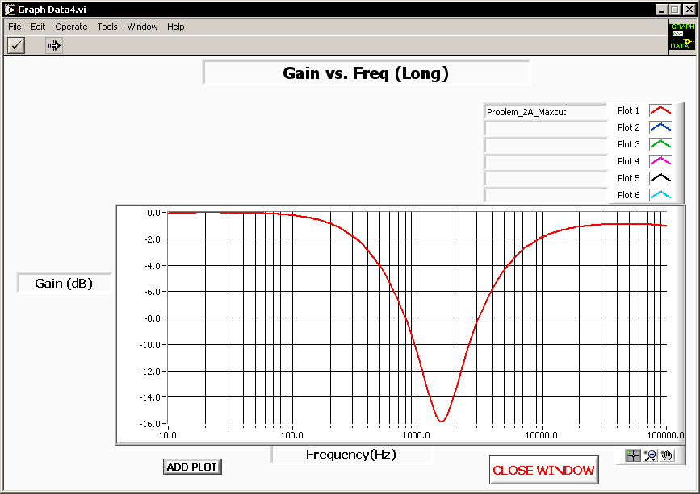
Figure 4: Max Cut CAT Plot

4. Analysis

As shown in Tables 1 & 2, the relative differences of each circuit between the design requirements and the PSpice plots were quite small. Table 3’s higher error calculations can be partially attributed to the number of data points taken in the CAT system; as more data points are taken, less interpolation between points would be required.
See PSpice plots in Appendix A. Circuit 1 reaches its design pass-band gain of 16.03 dB while Circuit 2 only obtains 15.731 dB. Circuit 1 also reaches 0 dB, or 1 V/V at high frequencies while Circuit 2 levels off at 0.5 dB, or 1.059 V/V. The only difference between these two circuits is the gyrator type used to simulate the inductor value calculated as shown in Section 3.1 Equation 2. The GIC used in Circuit 1 only simulates the ideal inductor calculated plus its series resistance losses as R_{S}. The simple gyrator used in Circuit 2 simulates the ideal inductor calculated, its series resistance R_{S} and its parallel resistance R_{P}. R_{P} is the simulated factor in Circuit 2 which causes it not to match up with the PSpice plot of Circuit 1. At resonance, Circuit 2’s simulated inductor now sees parallel losses associated with it. Also at higher frequencies, the simulated inductor should look like an open circuit or infinite impedance, but due to Circuit 2’s R_{P} value (given by subtracting R_{S} from R₁) the open circuit will never reach higher than that shown in Equation 7 below. Also, given that Circuit 1 requires R₁’s presence in order to simulate a given inductor (ie. It cannot simply be removed from the circuit), R_{P} will thus always be present in the simple type gyrator as shown in Circuit 2.
Equation 7: Circuit 2's Rp Limitation

Table 4 below shows the serial numbers for the equipment used in lab.

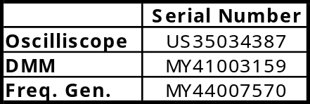
Table 4: Lab Equip. S/N

4.1 Gyrator Circuit 1

The GIC has a relatively high component count when compared to its small brother, the simple gyrator, as shown in Circuit 2. This high component count would also imply that its signal-to-noise ratio (SNR) is also lower, or worse off than that of the simple gyrator. The biggest advantage is that the GIC does not have a requirement to model the parallel resistance R_{P} of the inductor and thus it is able to match design requirements more accurately. The disadvantage is that it is more complicated and expensive to produce than the simple gyrator.

4.2 Gyrator Circuit 2

The simple gyrator has a small component count when compared to the GIC. For the most part, its SNR will be higher than the GIC. Due to the simple gyrator’s requirement to simulate R_{P} as discussed within Section 4, careful attention must be made to R₁‘s upper limit. R₁ must be selected such that it is both maximized in order to maintain a high R_{P} and minimized in order to increase the gyrator’s SNR. A high R₁ value will create unwanted thermal noise, whereas a low R₁ will generate unnecessary losses within the simulated inductor.

5. Conclusion

In general, these gyrator circuits have a much greater immunity to electromagnetic interference (EMI) than their counterpart the inductor (frequency dependent). They are also smaller in size and will usually cost less. However, if high frequencies are being processed it still may be better to use the inductor as its size will have decreased as well as its sensitivity to EMI. These active devices will also have slew rate limitations where an inductor will not. The gyrator must also be used where at least one pole of the inductor is connected to ground. These two types of gyrators cannot be used in a floating type application. A high current requirement, or rather a low R_{S} value, would also render the gyrator impractical.

6. Appendix A: Lab Documents

